Medicine Inventory and Supplier Management System
MediStock — Milestone 2 Report
________________________________________________________________________

1. Introduction
MediStock is a full-stack platform built to make day-to-day inventory handling easier for pharmacies and healthcare facilities. It gives staff a single place to manage medicines, suppliers, stock levels, expiry timelines, and item lookup.
During this milestone (Week 4), the primary focus was building and wiring up the medicine inventory APIs, the supplier management module, the inventory dashboard, stock-level tracking, and the medicine search/filter experience.

2. Objectives
- Build REST APIs to manage the medicine inventory.
- Deliver a working supplier management module.
- Design an interactive inventory dashboard.
- Keep medicine stock counts accurate at all times.
- Add search and filter tools for medicines.
- Connect the frontend to the backend APIs.
- Test the core inventory and supplier workflows.

3. Task 1 — Implement Medicine Inventory APIs

Functional requirements:
- Create a new medicine record.
- List every medicine in the system.
- Fetch a single medicine by its ID.
- Edit an existing medicine's details.
- Remove a medicine from inventory.
- Validate the data entered for a medicine.
- Test each endpoint for correctness.

Fields captured per medicine:
- Medicine ID
- Medicine Name
- Category
- Manufacturer
- Batch Number
- Expiry Date
- Price
- Quantity
- Minimum Stock Level
- Supplier Name

Medicine API Operations:
Method | Endpoint | Purpose
POST | /medicines | Create a medicine
GET | /medicines | List all medicines
GET | /medicines/{id} | Fetch one medicine
PUT | /medicines/{id} | Update a medicine
DELETE | /medicines/{id} | Remove a medicine

Expected result: every endpoint above should complete its CRUD action correctly and return sensible responses for both valid and invalid requests.
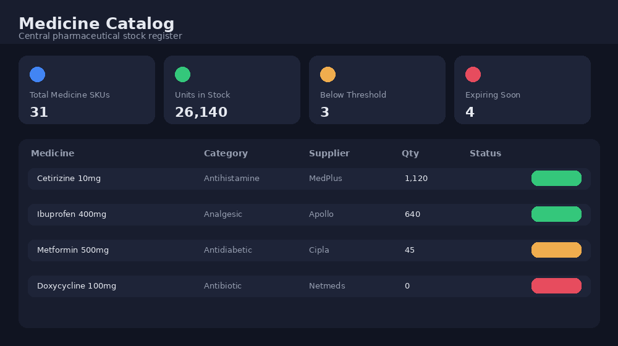
Fig 1 — Medicine catalog view with stock summary cards
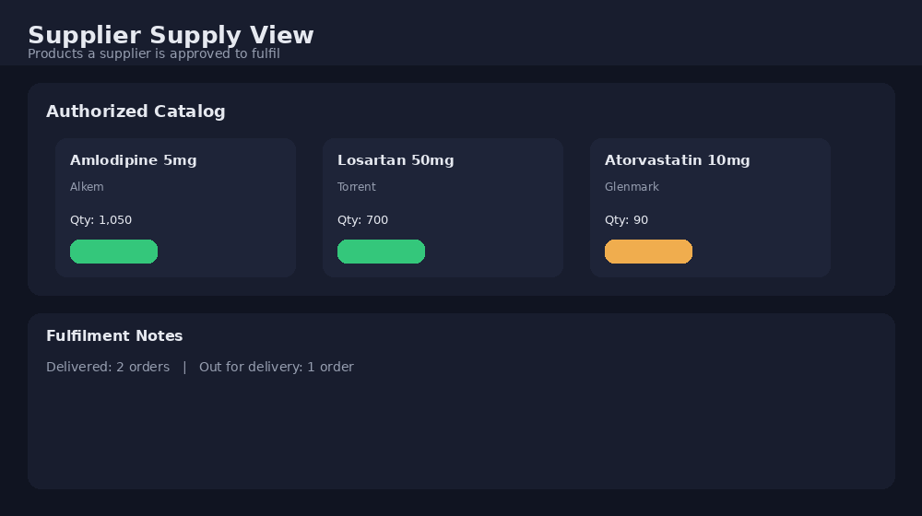
Fig 2 — Supplier-side view of items they are authorized to supply

4. Task 2 — Build the Supplier Management System
The supplier module keeps supplier records organized and links each supplier to the medicines they supply.

Capabilities provided to users:
- Register a new supplier.
- Browse the full supplier list.
- Update supplier details.
- Remove a supplier.
- Search across suppliers.
- Link suppliers to specific medicines where needed.

Fields captured per supplier:
- Supplier ID
- Supplier Name
- Contact Person
- Phone Number
- Email
- Address
Expected result: the supplier screen should support full create/read/update/delete actions and make it simple to keep supplier records current.
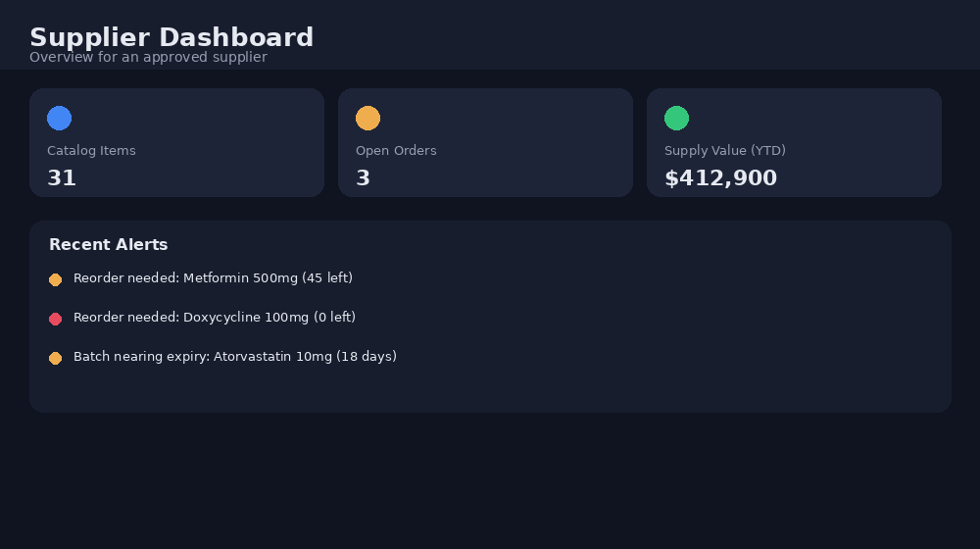
Fig 3 — Supplier-facing dashboard summary
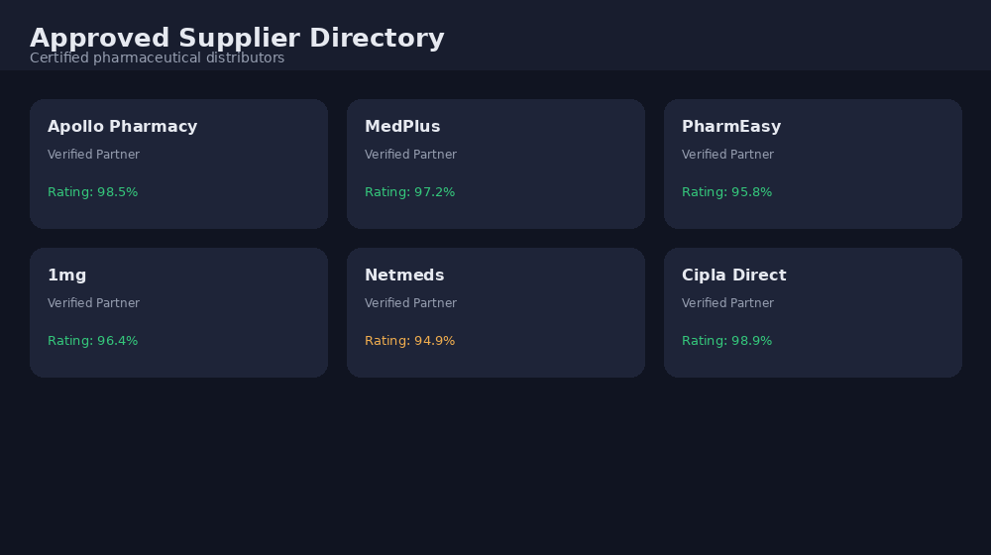
Fig 4 — Directory of approved suppliers
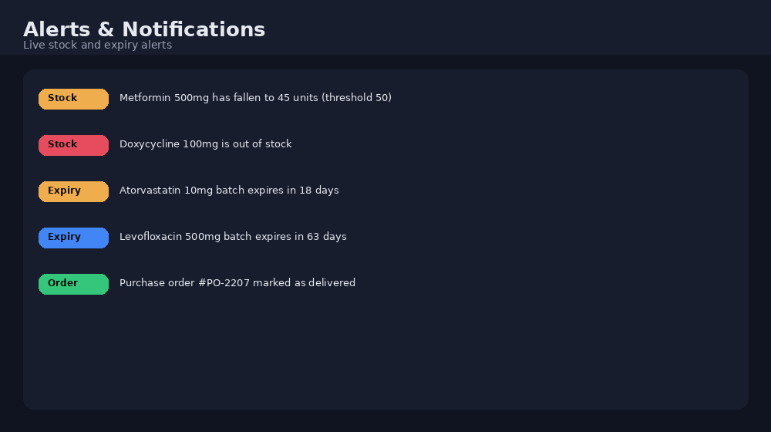
Fig 5 — Supplier alert and notification feed

5. Task 3 — Create Medicine Dashboard Pages
The dashboard gives a snapshot of the current inventory the moment a user logs in.

Dashboard tiles:
- Total Medicines — count of all medicine records.
- Available Stock — medicines with healthy stock levels.
- Low-Stock Medicines — items under their minimum stock level.
- Expired Medicines — items past their expiry date.
- Near-Expiry Medicines — items approaching expiry, where enabled.
The dashboard needs to stay lightweight, responsive on any screen size, wired to the live backend data, and refreshed automatically as inventory changes.

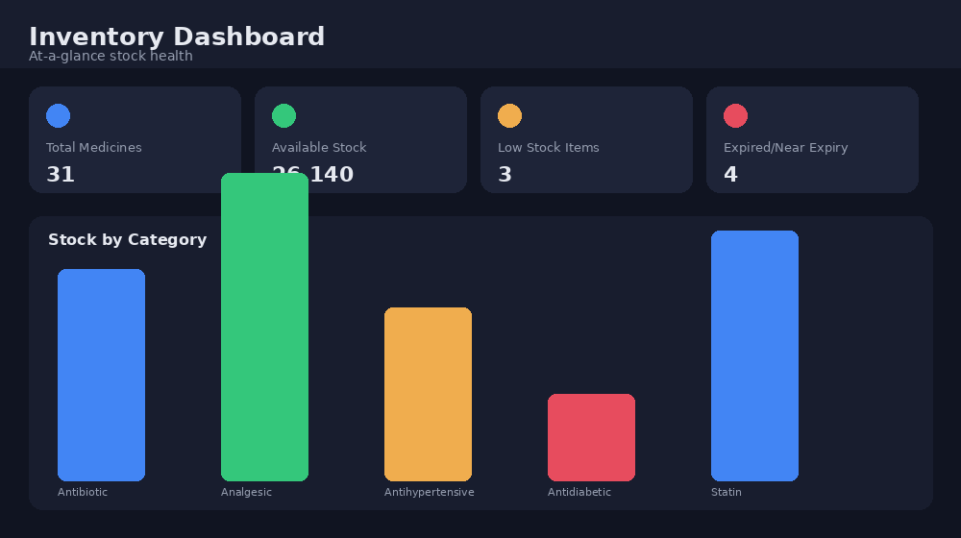
Fig 6 — Inventory dashboard with category breakdown

6. Task 4 — Implement Stock Tracking Functionality
Stock tracking keeps each medicine's on-hand quantity correct as it moves through the system.

Stock recalculates whenever:
- A new medicine entry is created.
- Medicine is dispensed or sold.
- New stock is received.
- A quantity is corrected manually.

Worked example:
Starting quantity: 100 units. 20 units are dispensed, leaving 80. A delivery of 50 units then arrives, bringing the balance to 130 units.

Low-stock detection:
The current quantity is compared against the configured minimum stock level. For instance, a medicine sitting at 5 units with a minimum threshold of 10 is automatically flagged as Low Stock.
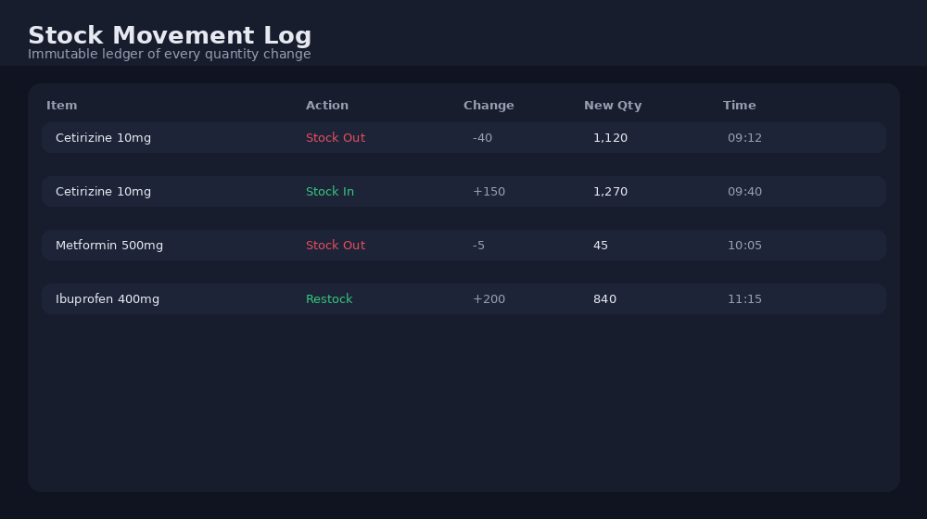
Fig 7 — Stock movement / audit log

7. Task 5 — Add Medicine Search and Filtering
Users can locate medicines quickly using:

Search by:
- Medicine name
- Category
- Supplier

Filter by:
- Available Stock
- Low Stock
- Expired Medicines
- Near-Expiry Medicines, where enabled
Expected result: search and filter results should return matching medicines instantly, without forcing the user to scroll through the entire catalog.
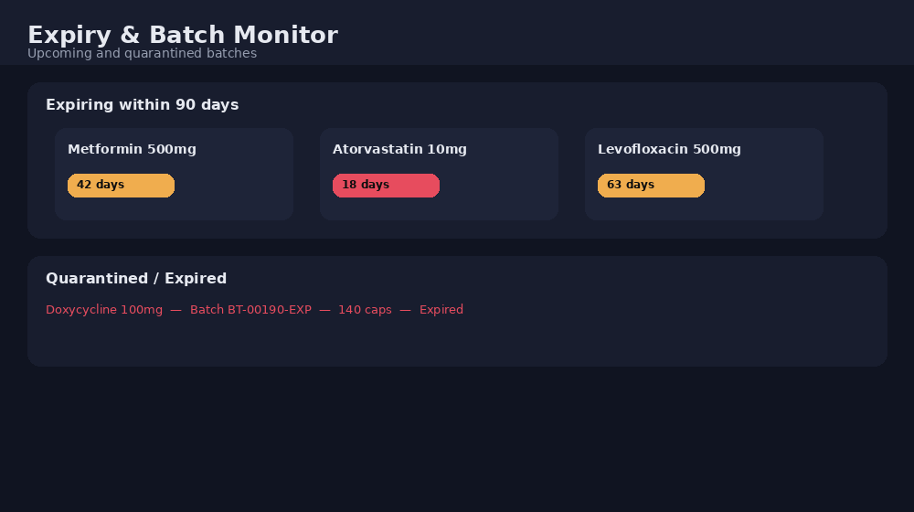
Fig 8 — Expiry monitoring and quarantined batches

8. Technology Stack
Layer | Technologies
Frontend | React.js, JavaScript, HTML, CSS, Axios, React Router
Backend | Java, Spring Boot, Spring Data JPA, Spring Security, REST APIs
Database | MySQL
Tooling | VS Code / NetBeans, Maven, Postman, Git & GitHub

9. How the System Fits Together
The React frontend talks to the Spring Boot backend entirely through REST calls.
Flow: User → React Frontend → REST API → Spring Boot Backend → MySQL Database

Example — adding a medicine:
A user fills in the medicine form, React fires a POST request, Spring Boot processes it and persists the record to MySQL, a response goes back to the frontend, and the dashboard figures update to reflect the new entry.

10. Testing Summary

Medicine module:
- Create, list, fetch-by-ID, update, and delete a medicine.
- Attempt lookup with an invalid medicine ID.
- Submit invalid or incomplete medicine data.

Supplier module:
- Create, list, update, and delete a supplier.
- Validate required supplier fields.

Stock module:
- Add stock, reduce stock, and restock a medicine.
- Confirm low-stock flags trigger correctly.
- Confirm dashboard counts match actual stock.

Search & filter:
- Search by medicine name, category, and supplier.
- Filter by available stock and low stock.
- Confirm expired/near-expiry items surface correctly.
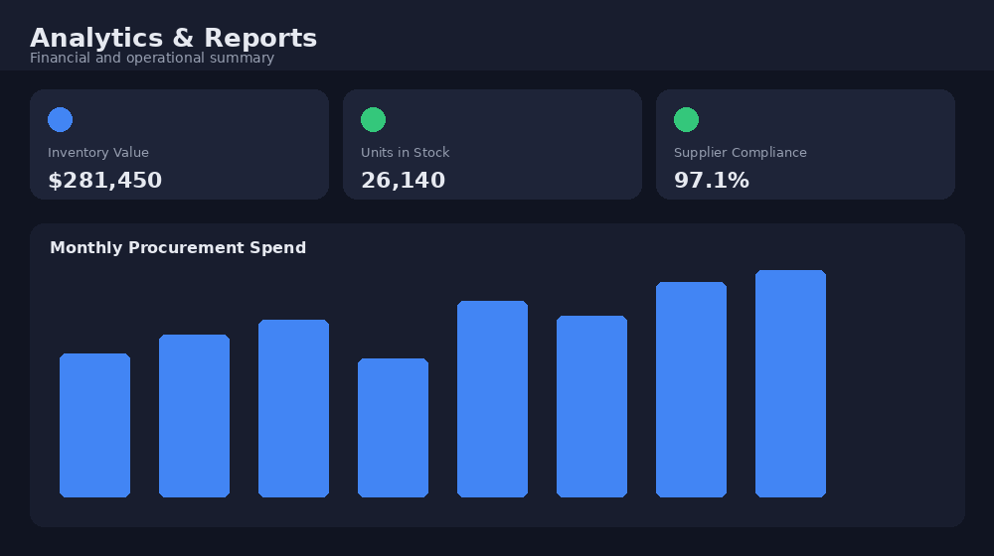
Fig 9 — Analytics and reporting summary
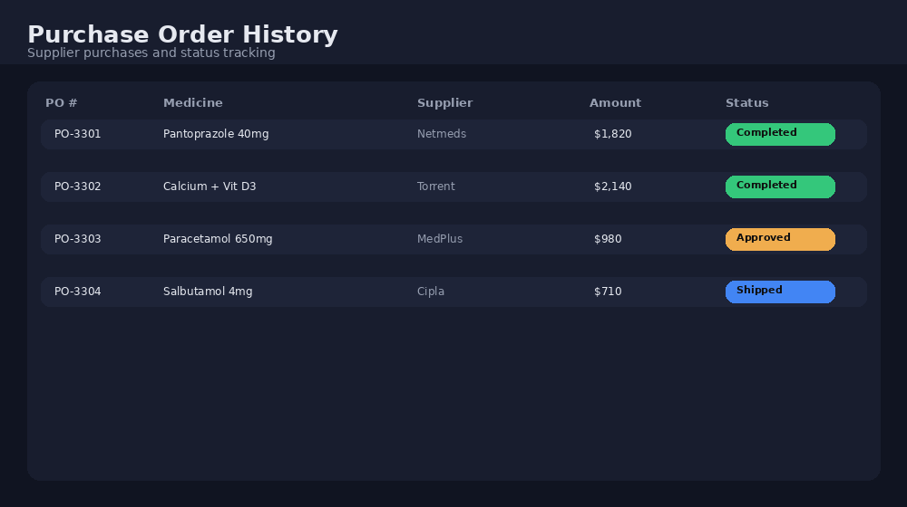
Fig 10 — Purchase order history

11. What This Milestone Should Deliver
- A working medicine inventory management system.
- Fully functional medicine CRUD APIs.
- A working supplier management module.
- Supplier-to-medicine linkage where applicable.
- An inventory dashboard.
- Reliable stock tracking.
- Automatic low-stock detection.
- Expiry / near-expiry detection, where implemented.
- Working medicine search.
- Working medicine filters.
- Frontend fully integrated with the backend.
- Core functionality verified through testing.

12. Definition of Done
The Week 4 milestone is considered complete once:
- Medicine CRUD APIs are built and tested.
- Supplier CRUD functionality works end to end.
- The dashboard shows accurate inventory figures.
- Stock quantities update correctly after every operation.
- Low-stock medicines are flagged automatically.
- Medicine search returns correct results.
- Medicine filters return correct results.
- Frontend and backend communicate without issues.
- The system presents accurate, usable inventory information.

13. Conclusion
This milestone lays down the core inventory functionality for MediStock. With the medicine APIs, supplier management, dashboard, stock tracking, and search/filter tools in place, the platform now has the foundation it needs for efficient pharmaceutical inventory management.
Once these pieces are fully tested and integrated, MediStock will give users an accurate, easy-to-read view of medicine and supplier status at all times.

